Part 1 state diagram

[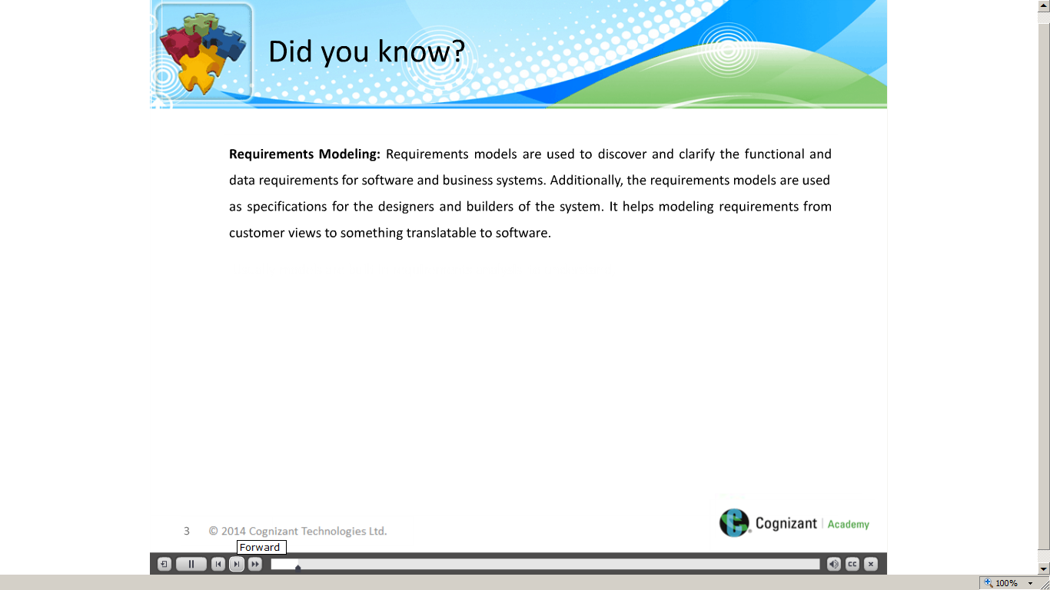](https://compass.learning.cognizant.com/elmprd/elearning/l2_ad_practisinglead_basiclearning_statediagrams/l2_ad_practicing%20lead_basic%20learning_state%20diagrams.htm)

[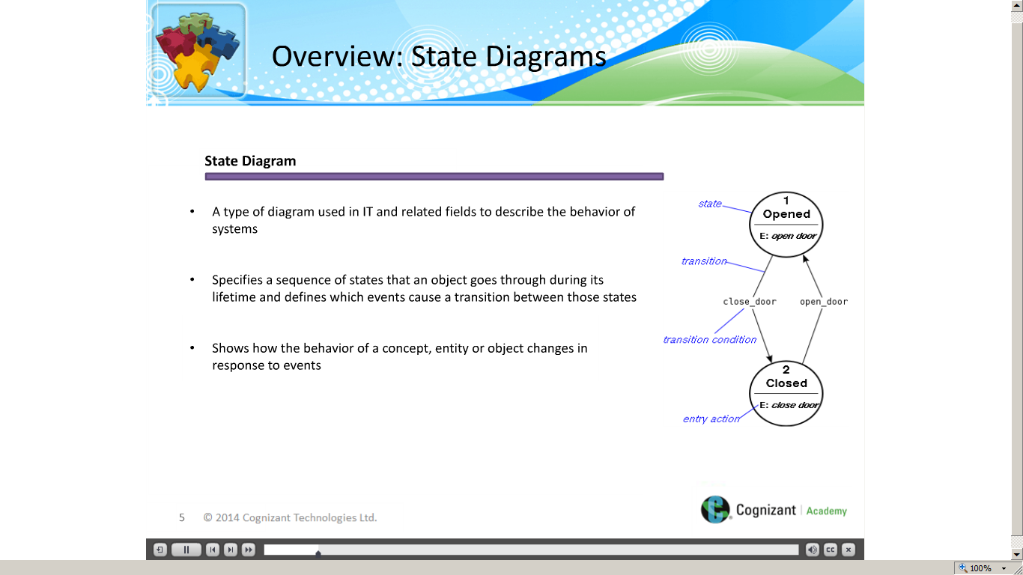](https://compass.learning.cognizant.com/elmprd/elearning/l2_ad_practisinglead_basiclearning_statediagrams/l2_ad_practicing%20lead_basic%20learning_state%20diagrams.htm)

[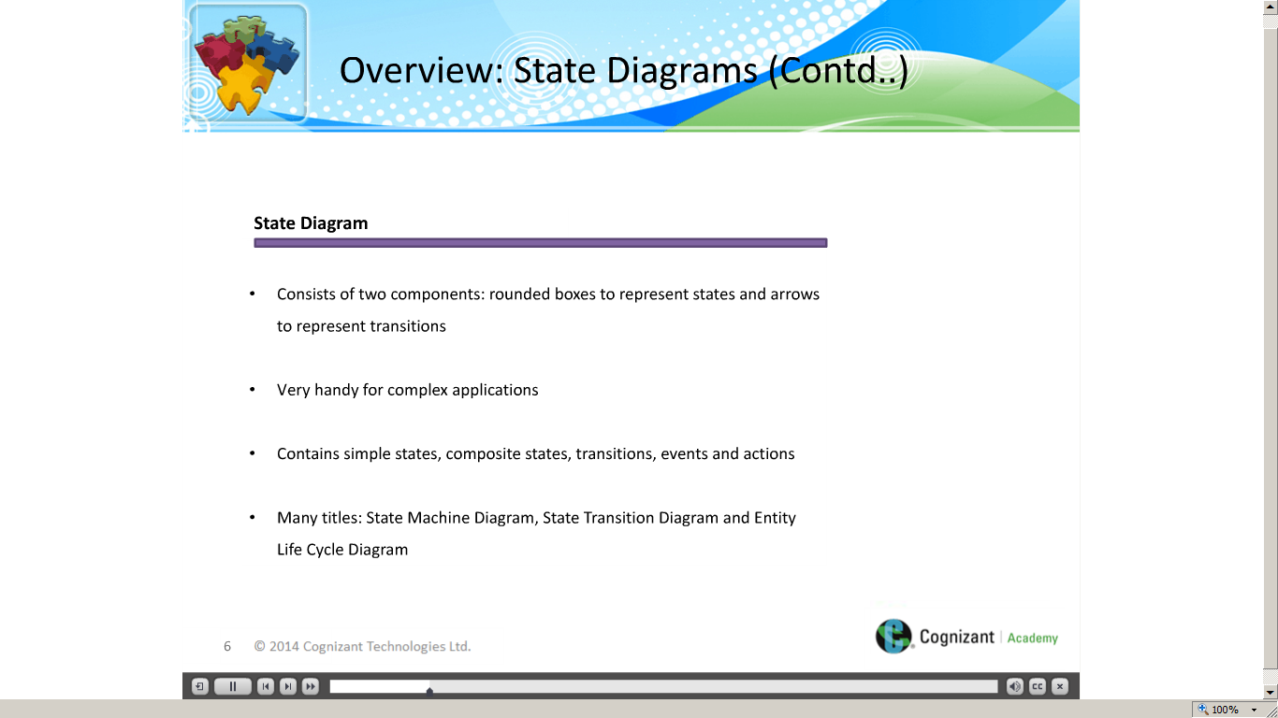](https://compass.learning.cognizant.com/elmprd/elearning/l2_ad_practisinglead_basiclearning_statediagrams/l2_ad_practicing%20lead_basic%20learning_state%20diagrams.htm)

[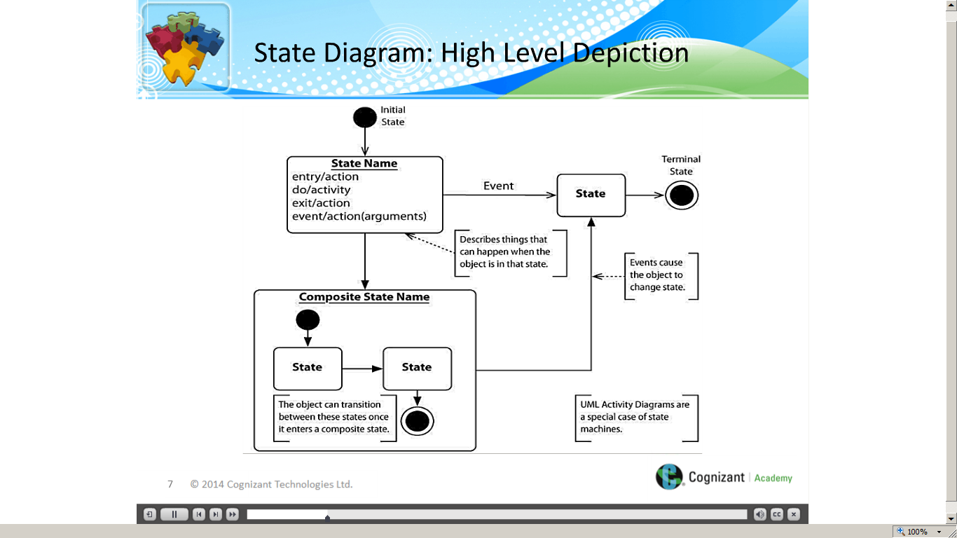](https://compass.learning.cognizant.com/elmprd/elearning/l2_ad_practisinglead_basiclearning_statediagrams/l2_ad_practicing%20lead_basic%20learning_state%20diagrams.htm)

[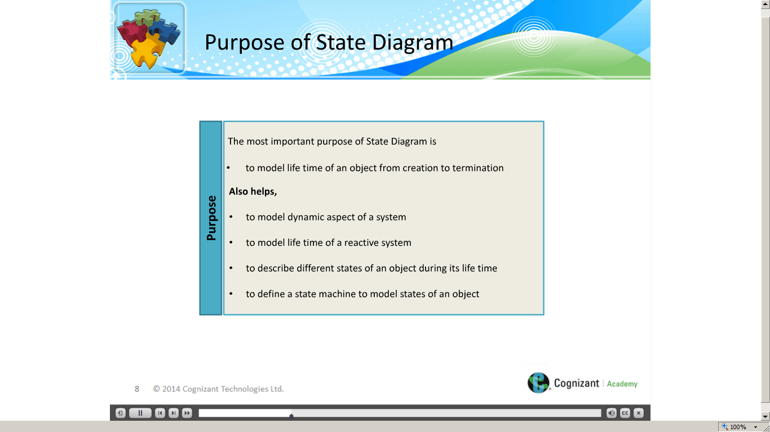](https://compass.learning.cognizant.com/elmprd/elearning/l2_ad_practisinglead_basiclearning_statediagrams/l2_ad_practicing%20lead_basic%20learning_state%20diagrams.htm)

[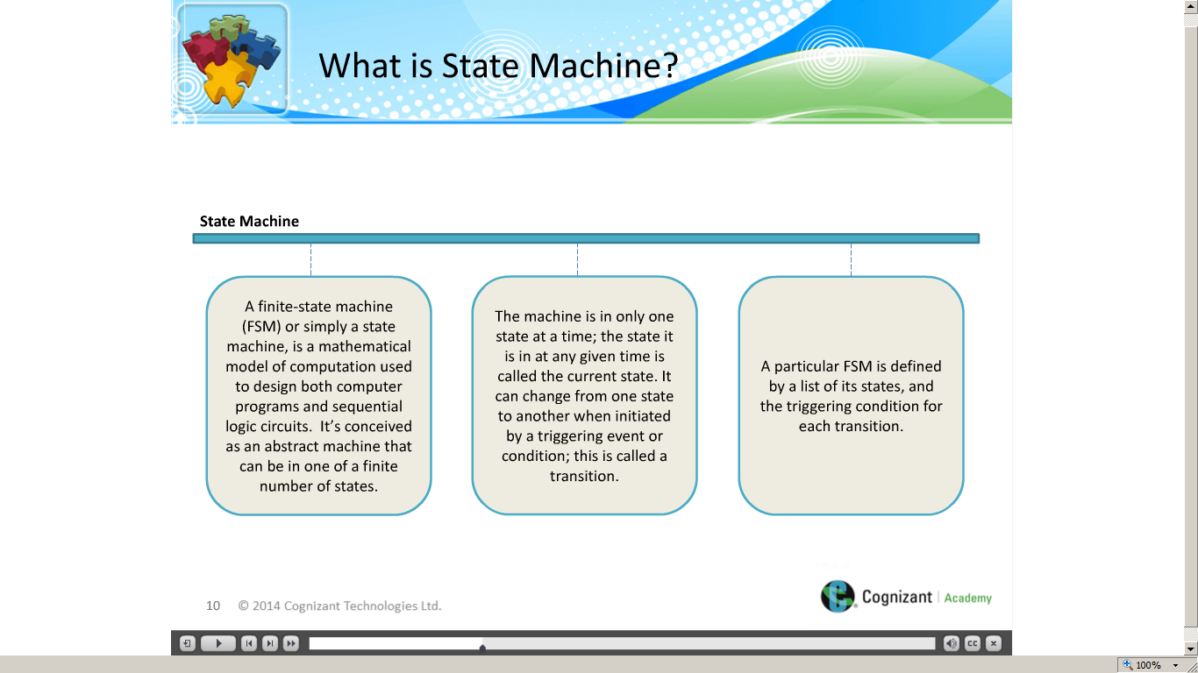](https://compass.learning.cognizant.com/elmprd/elearning/l2_ad_practisinglead_basiclearning_statediagrams/l2_ad_practicing%20lead_basic%20learning_state%20diagrams.htm)

[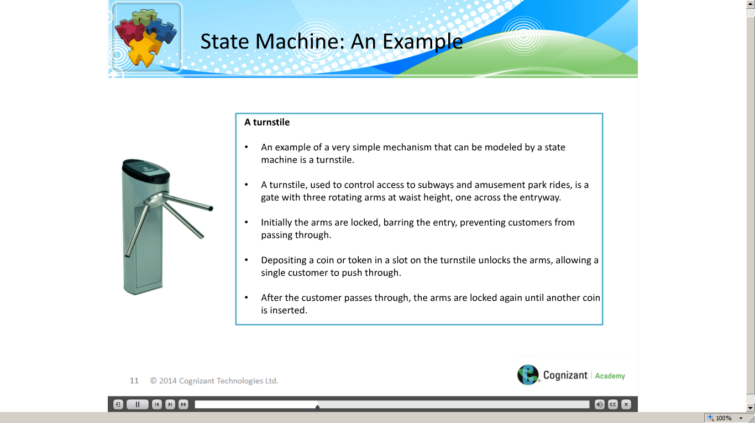](https://compass.learning.cognizant.com/elmprd/elearning/l2_ad_practisinglead_basiclearning_statediagrams/l2_ad_practicing%20lead_basic%20learning_state%20diagrams.htm)

[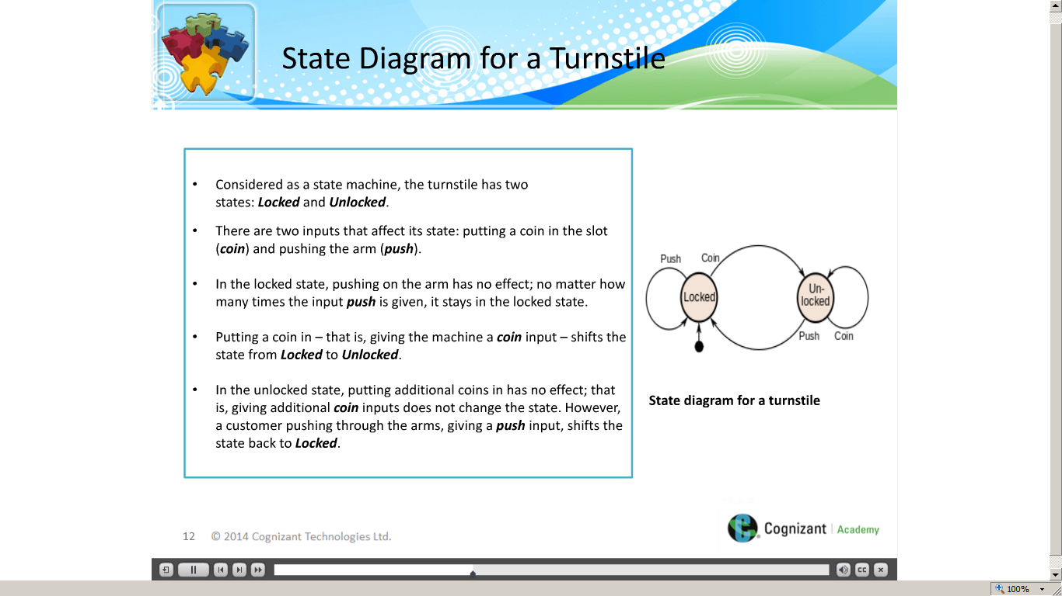](https://compass.learning.cognizant.com/elmprd/elearning/l2_ad_practisinglead_basiclearning_statediagrams/l2_ad_practicing%20lead_basic%20learning_state%20diagrams.htm)

[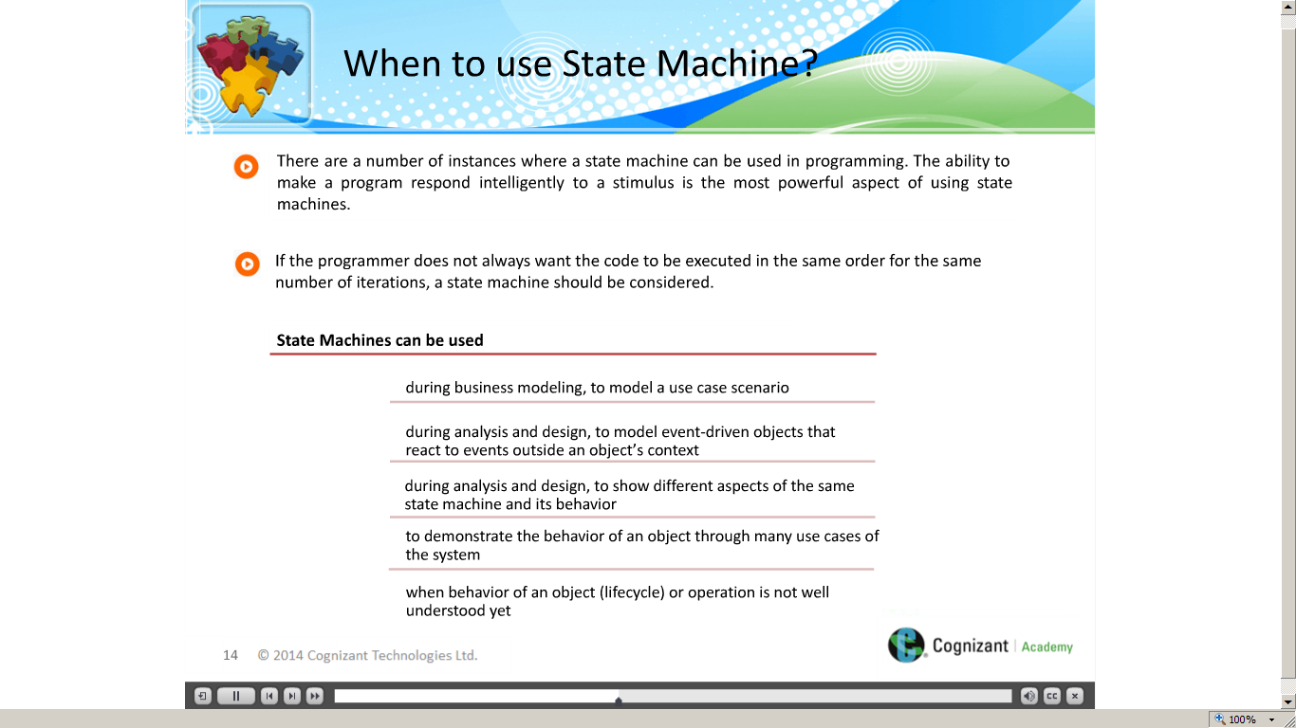](https://compass.learning.cognizant.com/elmprd/elearning/l2_ad_practisinglead_basiclearning_statediagrams/l2_ad_practicing%20lead_basic%20learning_state%20diagrams.htm)

[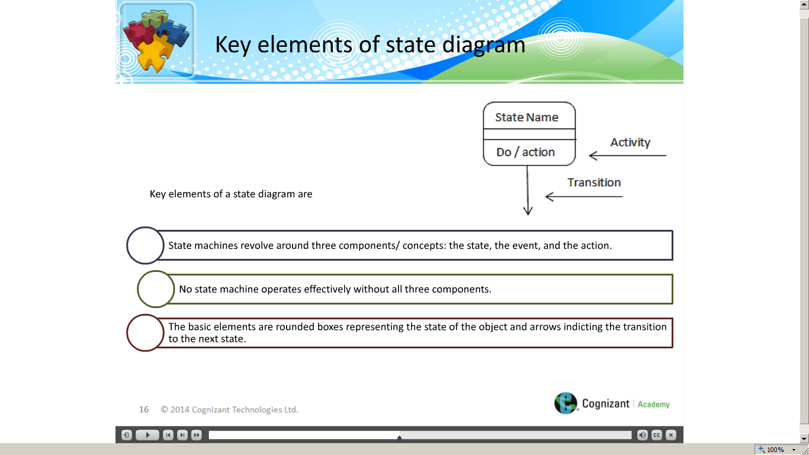](https://compass.learning.cognizant.com/elmprd/elearning/l2_ad_practisinglead_basiclearning_statediagrams/l2_ad_practicing%20lead_basic%20learning_state%20diagrams.htm)

[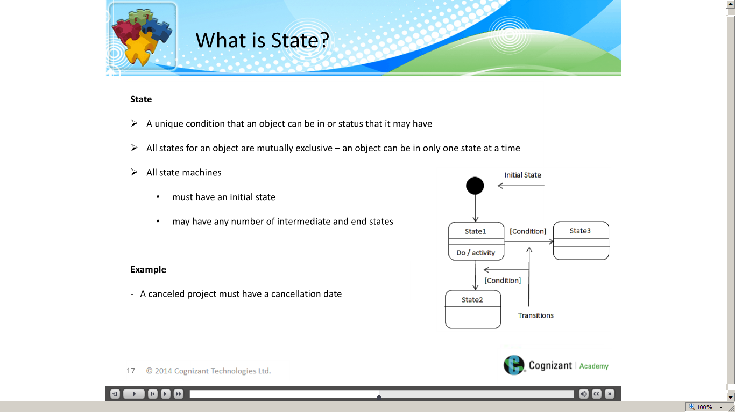](https://compass.learning.cognizant.com/elmprd/elearning/l2_ad_practisinglead_basiclearning_statediagrams/l2_ad_practicing%20lead_basic%20learning_state%20diagrams.htm)

[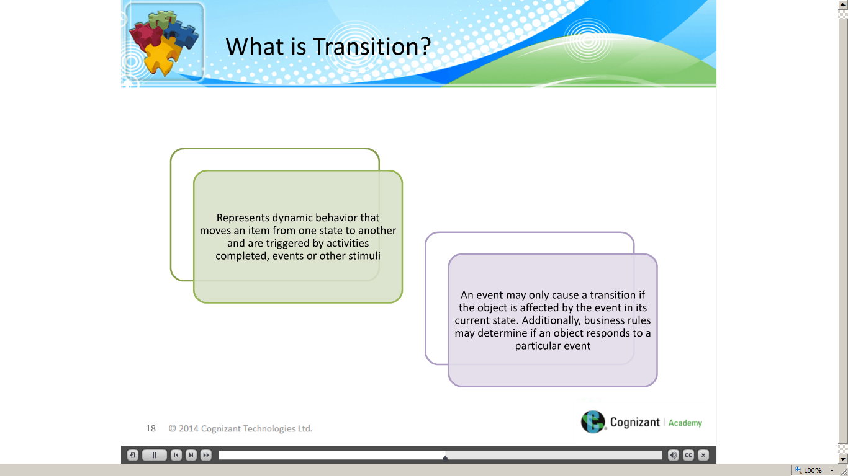](https://compass.learning.cognizant.com/elmprd/elearning/l2_ad_practisinglead_basiclearning_statediagrams/l2_ad_practicing%20lead_basic%20learning_state%20diagrams.htm)

[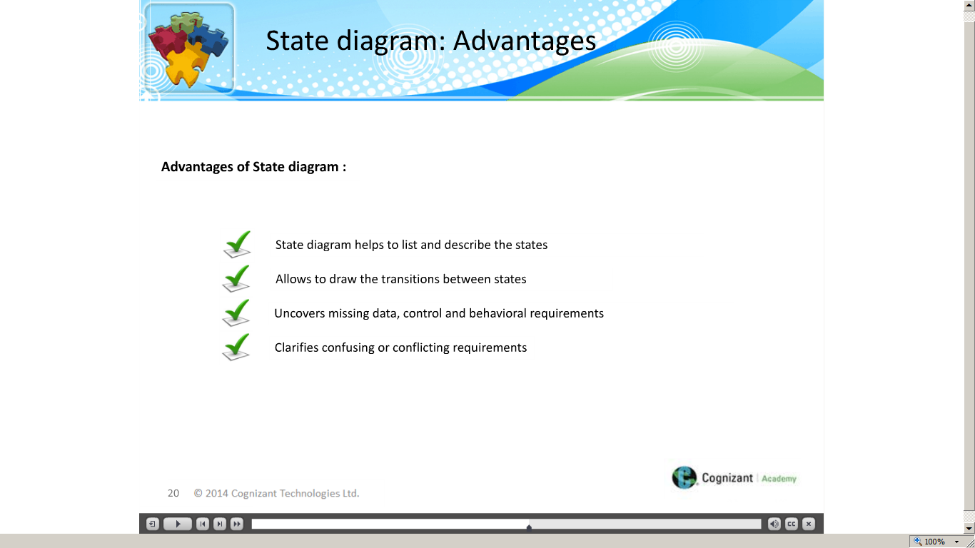](https://compass.learning.cognizant.com/elmprd/elearning/l2_ad_practisinglead_basiclearning_statediagrams/l2_ad_practicing%20lead_basic%20learning_state%20diagrams.htm)

[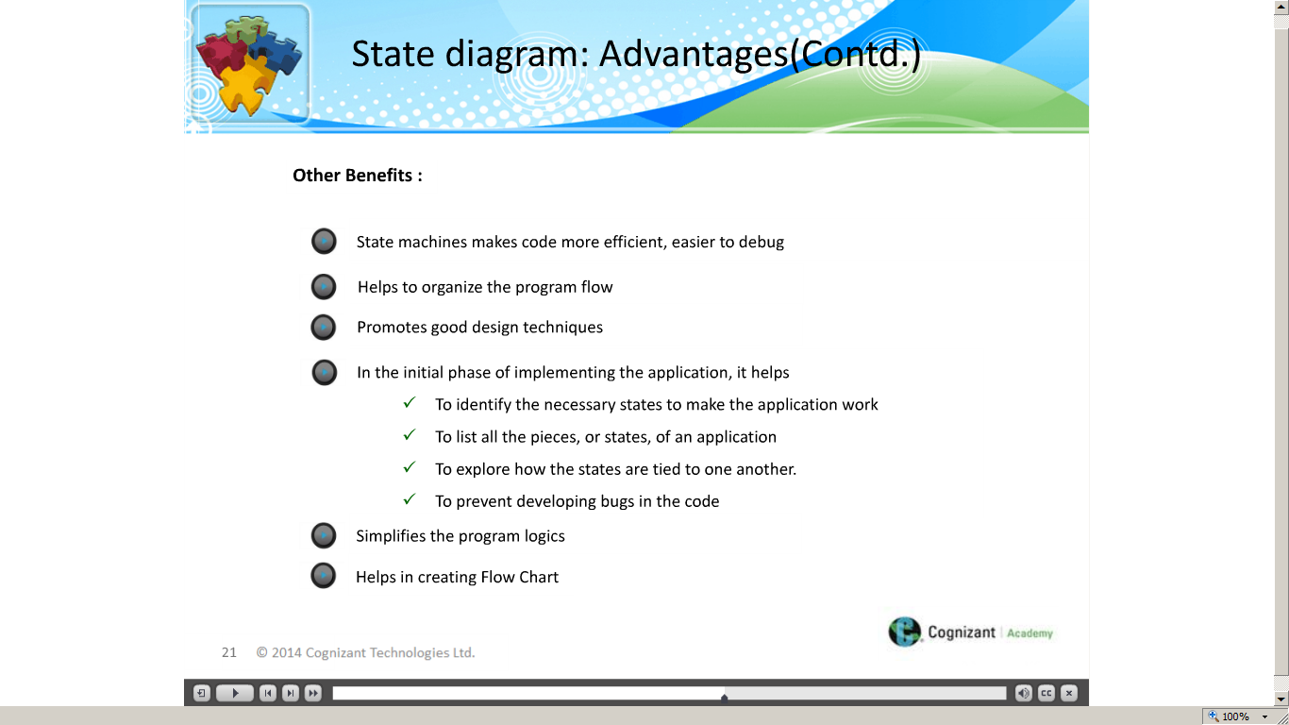](https://compass.learning.cognizant.com/elmprd/elearning/l2_ad_practisinglead_basiclearning_statediagrams/l2_ad_practicing%20lead_basic%20learning_state%20diagrams.htm)

[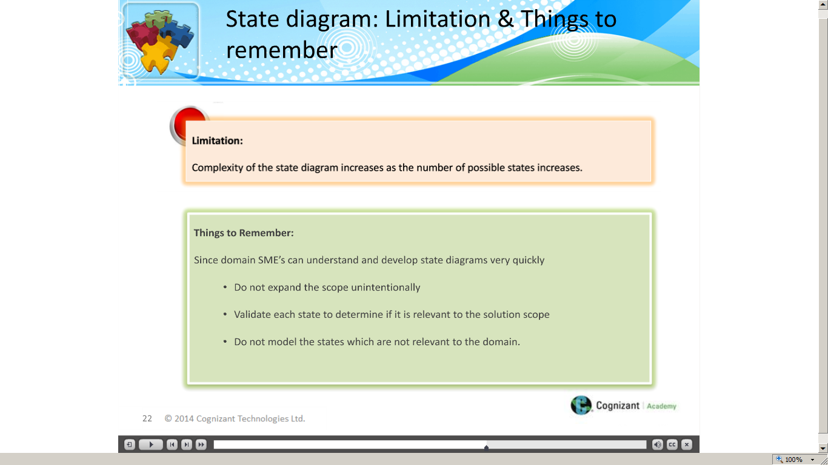](https://compass.learning.cognizant.com/elmprd/elearning/l2_ad_practisinglead_basiclearning_statediagrams/l2_ad_practicing%20lead_basic%20learning_state%20diagrams.htm)

[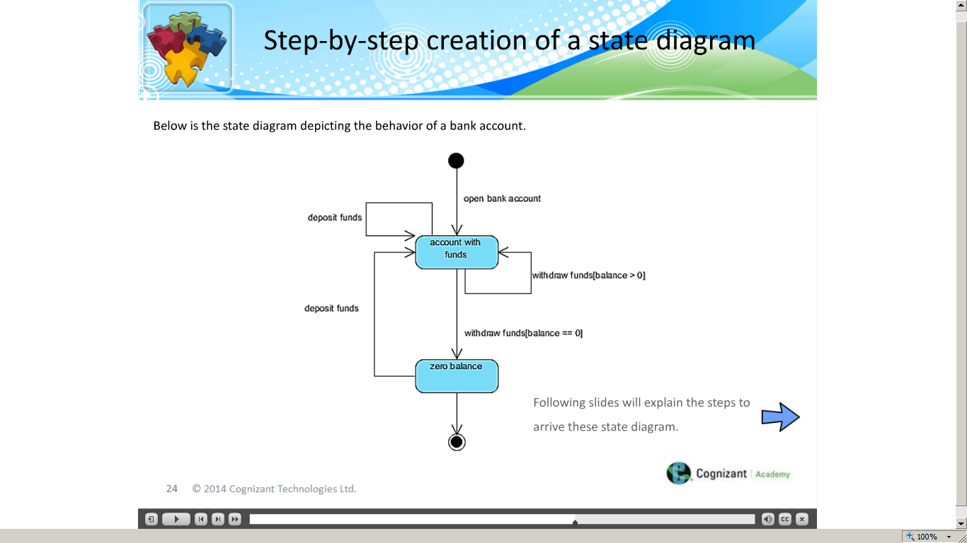](https://compass.learning.cognizant.com/elmprd/elearning/l2_ad_practisinglead_basiclearning_statediagrams/l2_ad_practicing%20lead_basic%20learning_state%20diagrams.htm)

[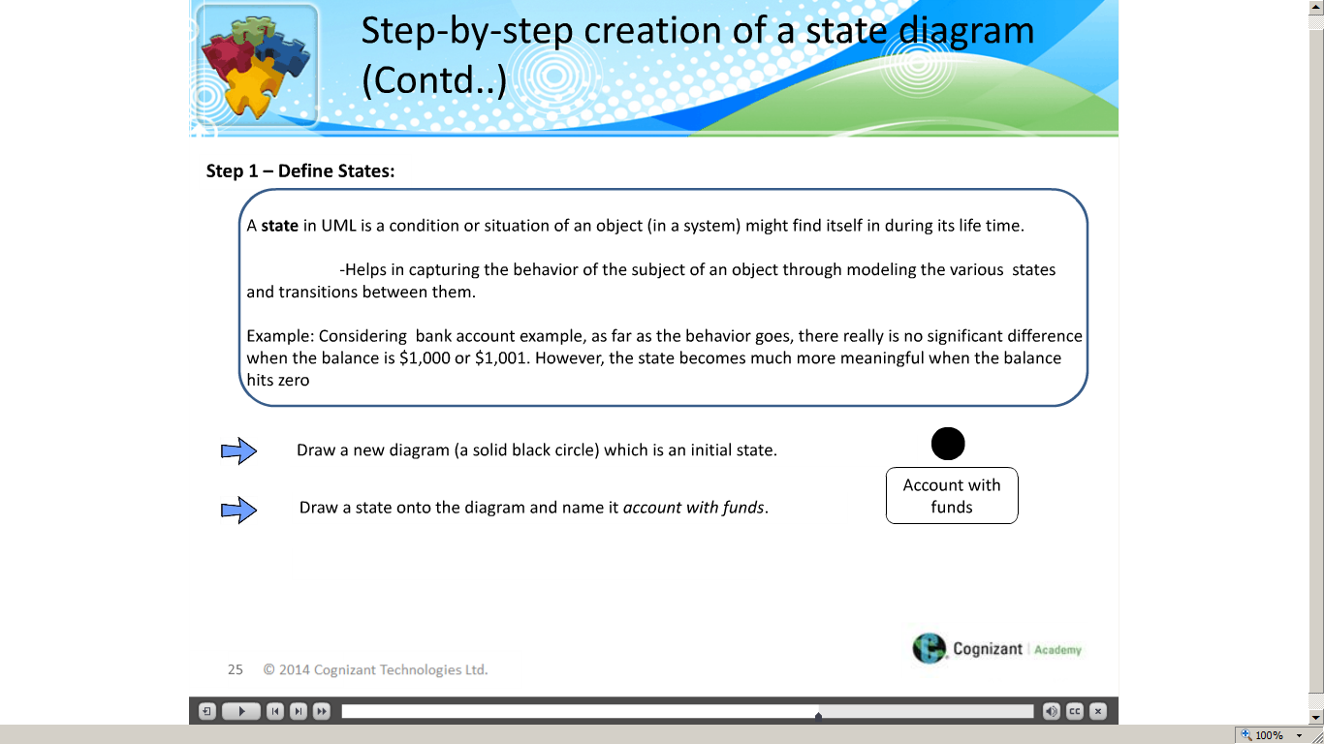](https://compass.learning.cognizant.com/elmprd/elearning/l2_ad_practisinglead_basiclearning_statediagrams/l2_ad_practicing%20lead_basic%20learning_state%20diagrams.htm)

[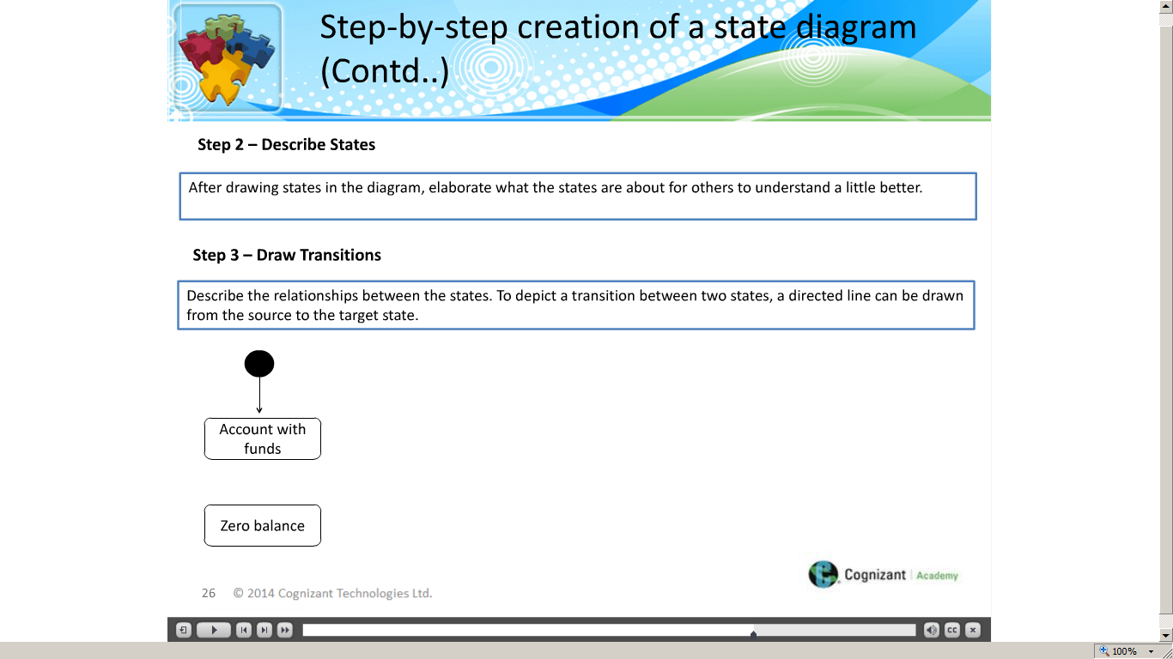](https://compass.learning.cognizant.com/elmprd/elearning/l2_ad_practisinglead_basiclearning_statediagrams/l2_ad_practicing%20lead_basic%20learning_state%20diagrams.htm)

[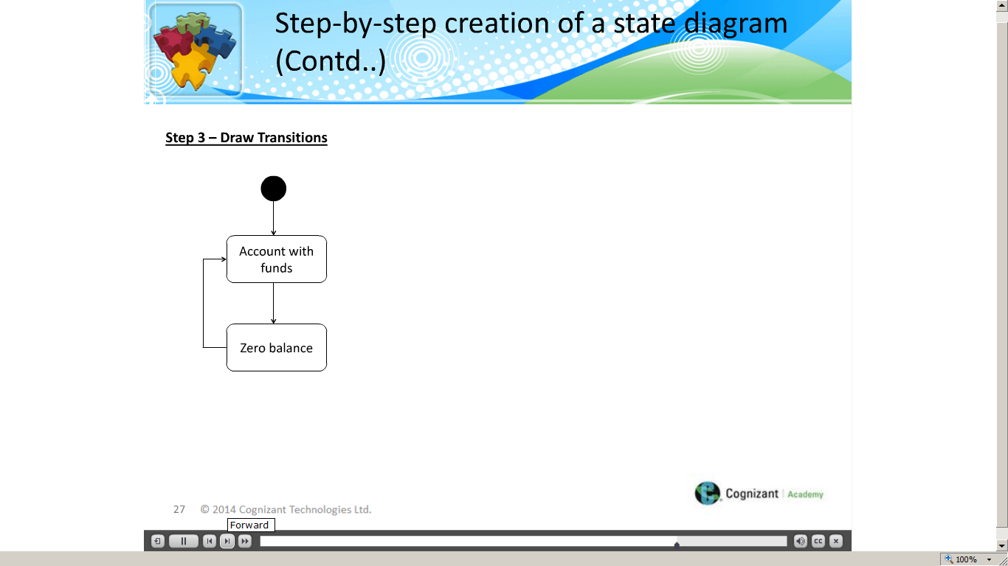](https://compass.learning.cognizant.com/elmprd/elearning/l2_ad_practisinglead_basiclearning_statediagrams/l2_ad_practicing%20lead_basic%20learning_state%20diagrams.htm)

[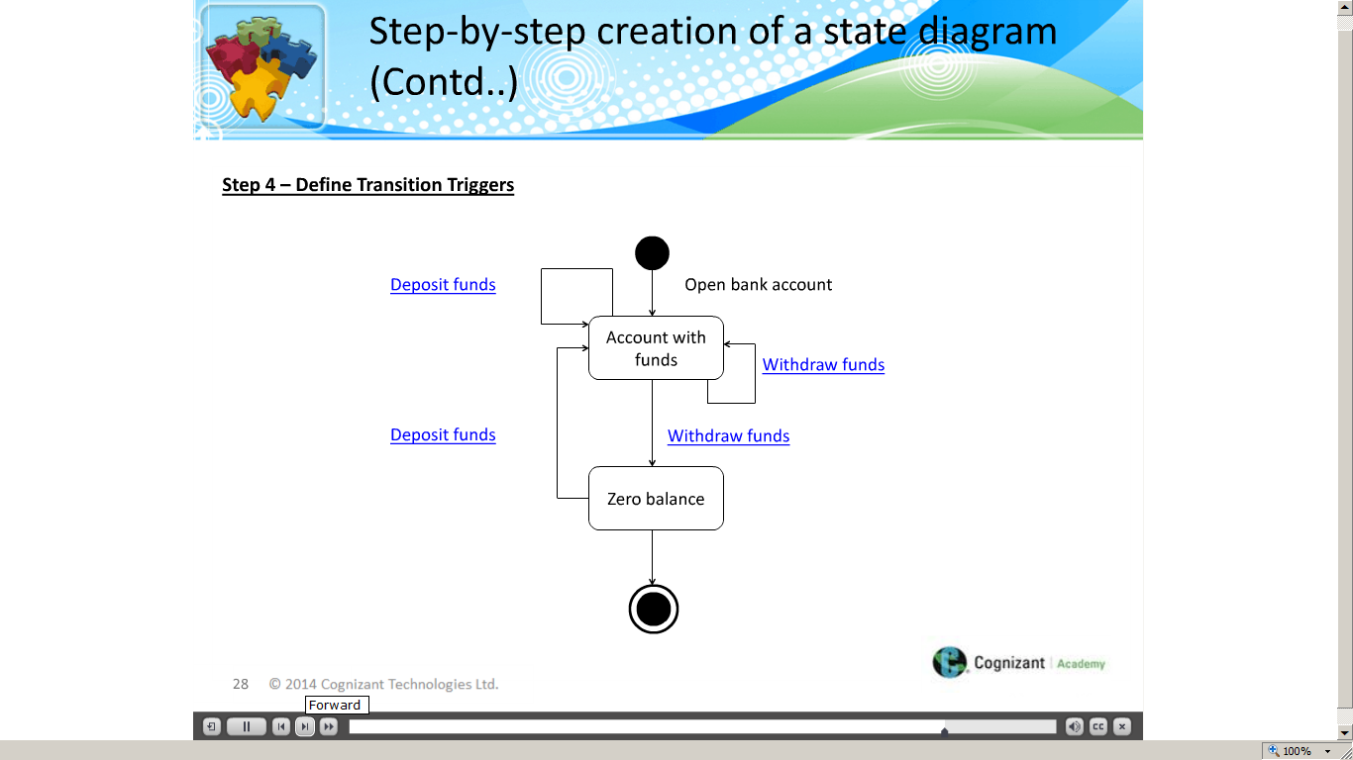](https://compass.learning.cognizant.com/elmprd/elearning/l2_ad_practisinglead_basiclearning_statediagrams/l2_ad_practicing%20lead_basic%20learning_state%20diagrams.htm)

[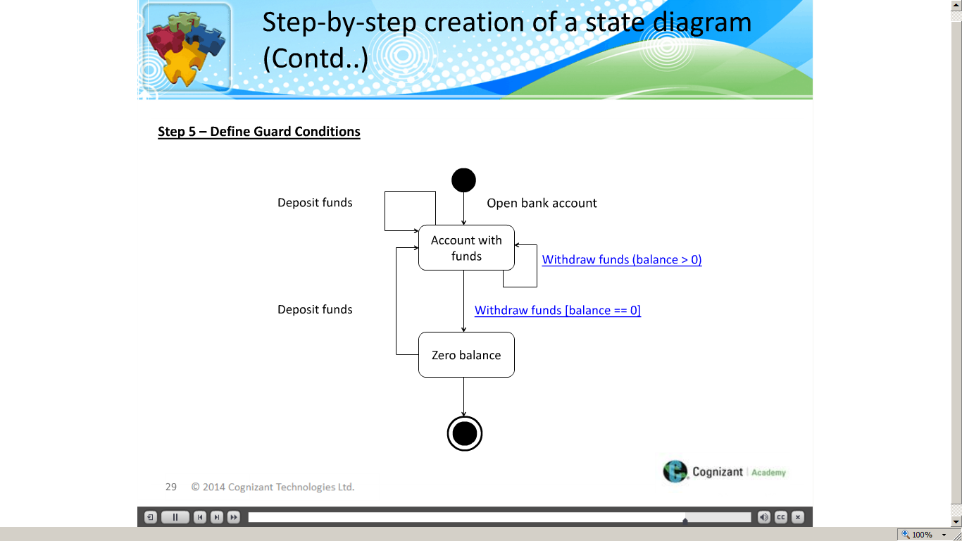](https://compass.learning.cognizant.com/elmprd/elearning/l2_ad_practisinglead_basiclearning_statediagrams/l2_ad_practicing%20lead_basic%20learning_state%20diagrams.htm)

[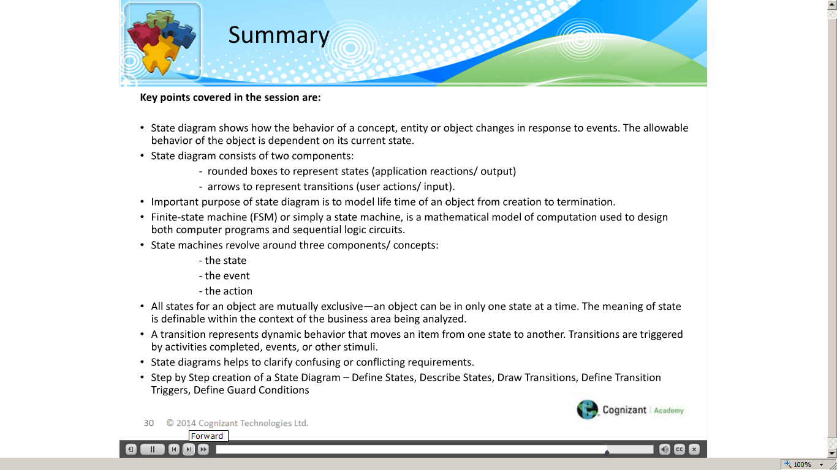](https://compass.learning.cognizant.com/elmprd/elearning/l2_ad_practisinglead_basiclearning_statediagrams/l2_ad_practicing%20lead_basic%20learning_state%20diagrams.htm)

Part 2 Case Study

Part 3

[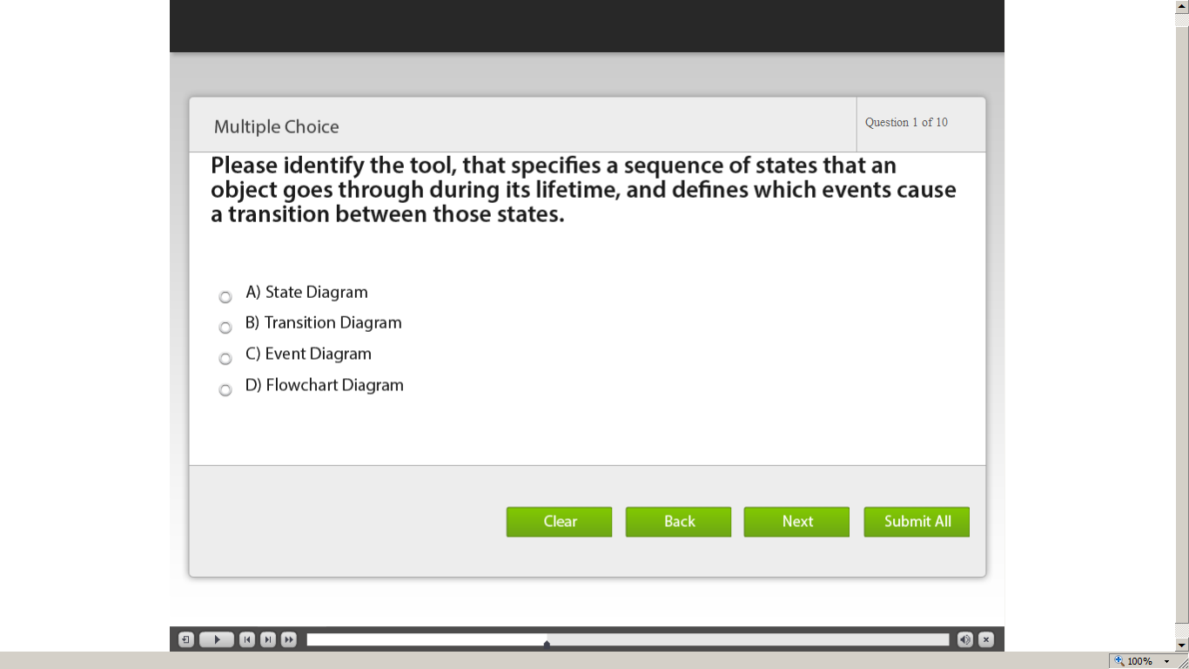](https://compass.learning.cognizant.com/elmprd/elearning/l2_ad_practicinglead_statediagrams_test_your_understanding/l2_ad_practicing%20lead_state%20diagrams_test%20your%20understanding.htm)

[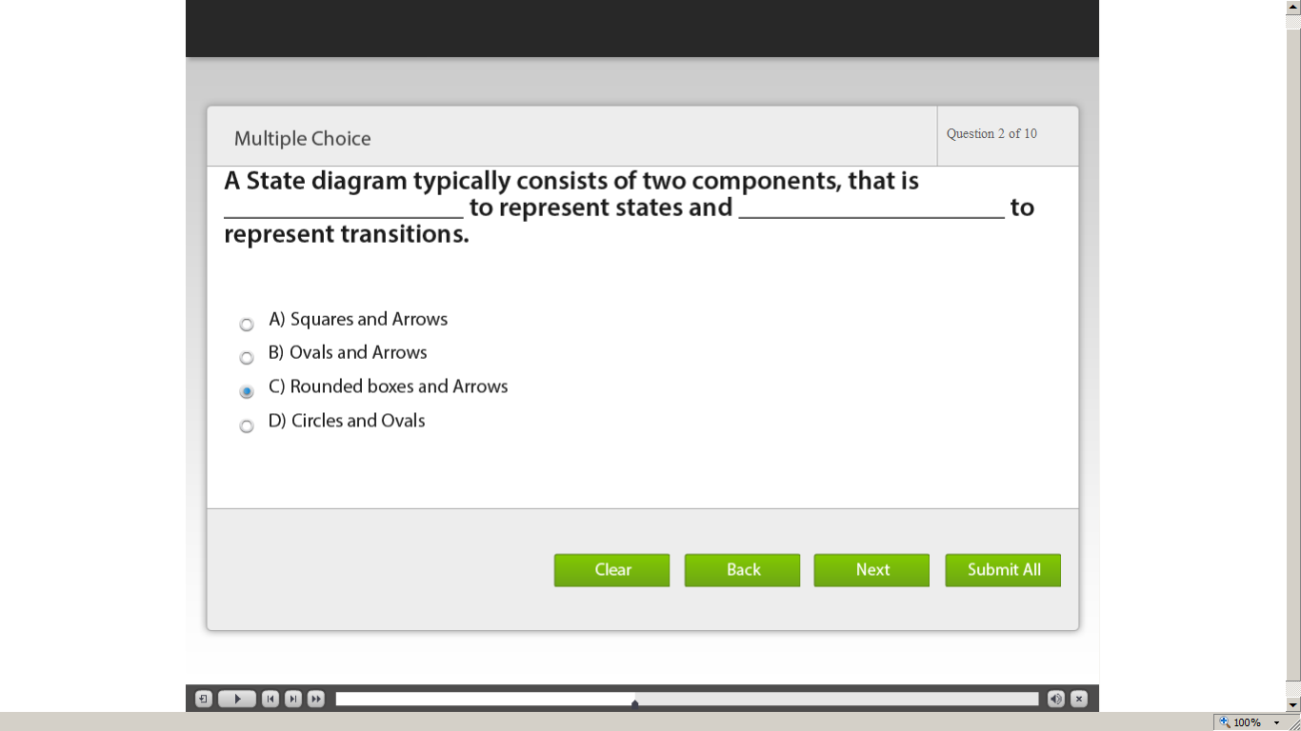](https://compass.learning.cognizant.com/elmprd/elearning/l2_ad_practicinglead_statediagrams_test_your_understanding/l2_ad_practicing%20lead_state%20diagrams_test%20your%20understanding.htm)

[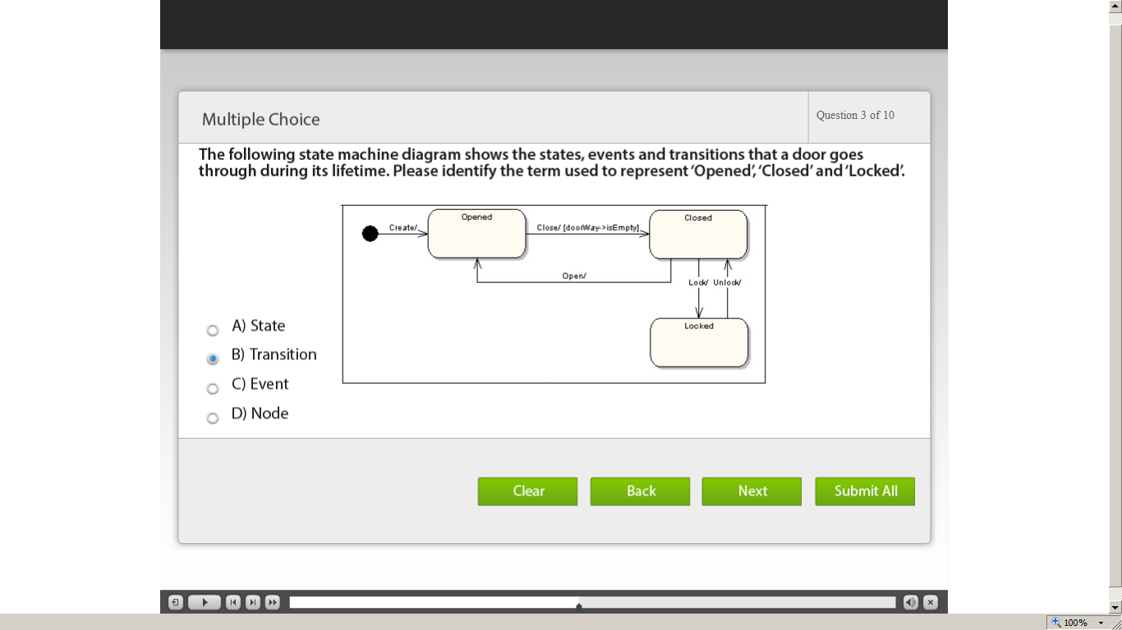](https://compass.learning.cognizant.com/elmprd/elearning/l2_ad_practicinglead_statediagrams_test_your_understanding/l2_ad_practicing%20lead_state%20diagrams_test%20your%20understanding.htm)

[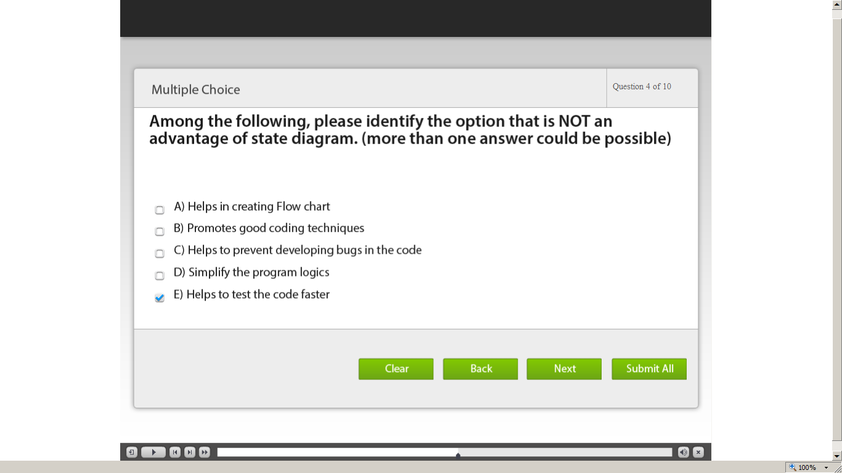](https://compass.learning.cognizant.com/elmprd/elearning/l2_ad_practicinglead_statediagrams_test_your_understanding/l2_ad_practicing%20lead_state%20diagrams_test%20your%20understanding.htm)

[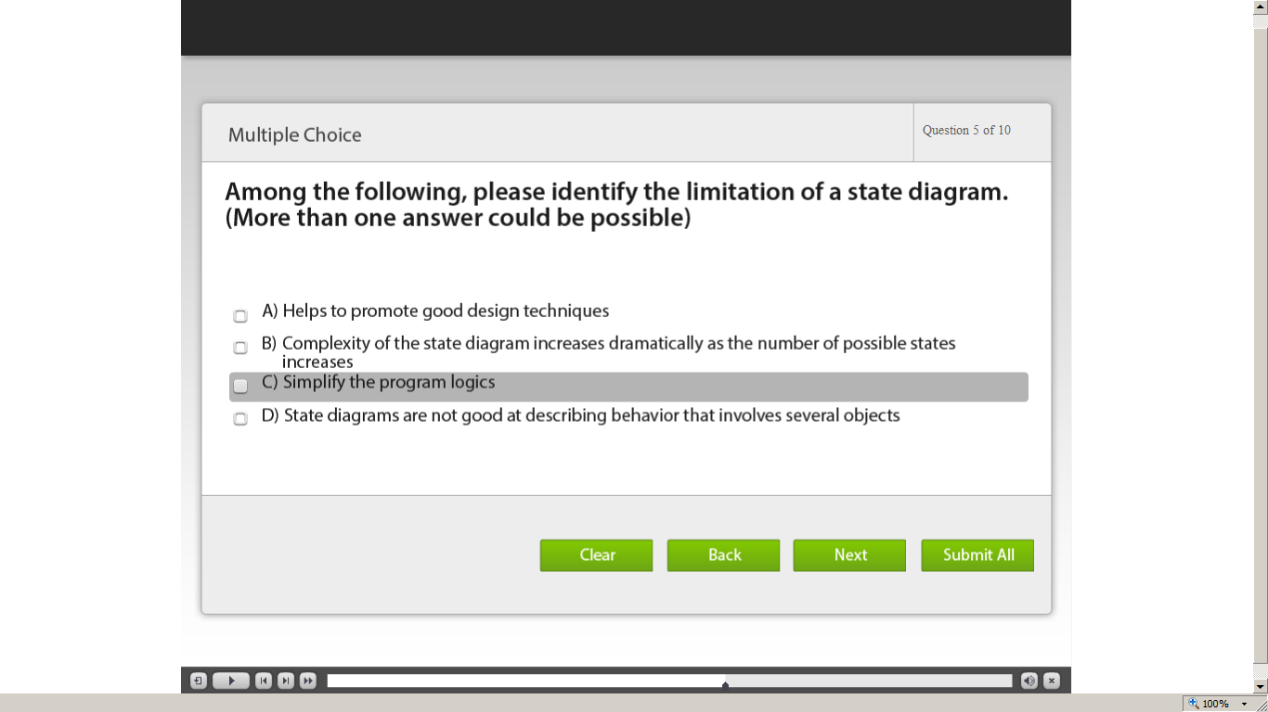](https://compass.learning.cognizant.com/elmprd/elearning/l2_ad_practicinglead_statediagrams_test_your_understanding/l2_ad_practicing%20lead_state%20diagrams_test%20your%20understanding.htm)

[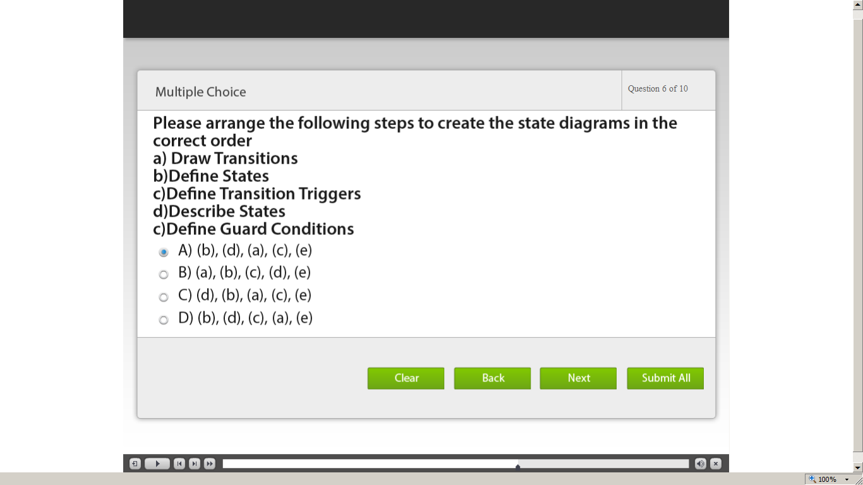](https://compass.learning.cognizant.com/elmprd/elearning/l2_ad_practicinglead_statediagrams_test_your_understanding/l2_ad_practicing%20lead_state%20diagrams_test%20your%20understanding.htm)

[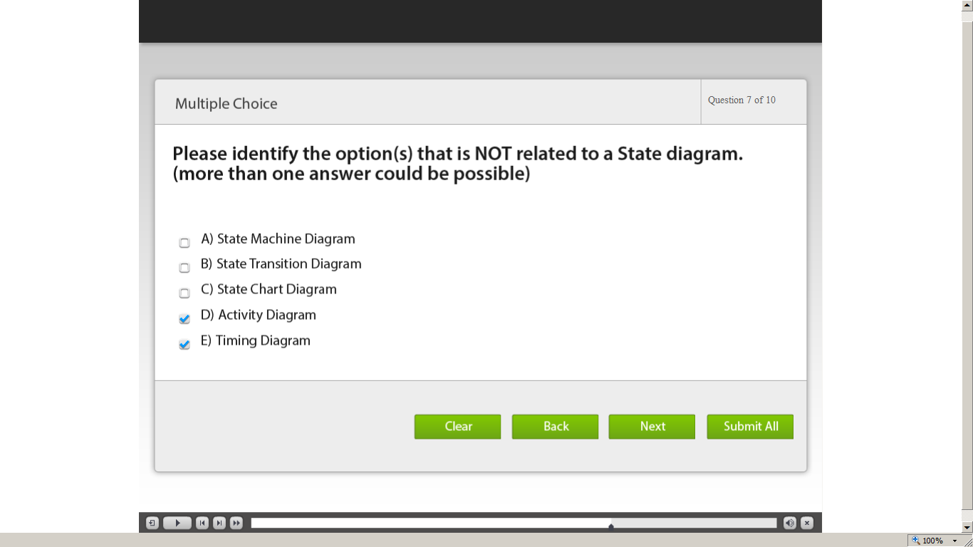](https://compass.learning.cognizant.com/elmprd/elearning/l2_ad_practicinglead_statediagrams_test_your_understanding/l2_ad_practicing%20lead_state%20diagrams_test%20your%20understanding.htm)

[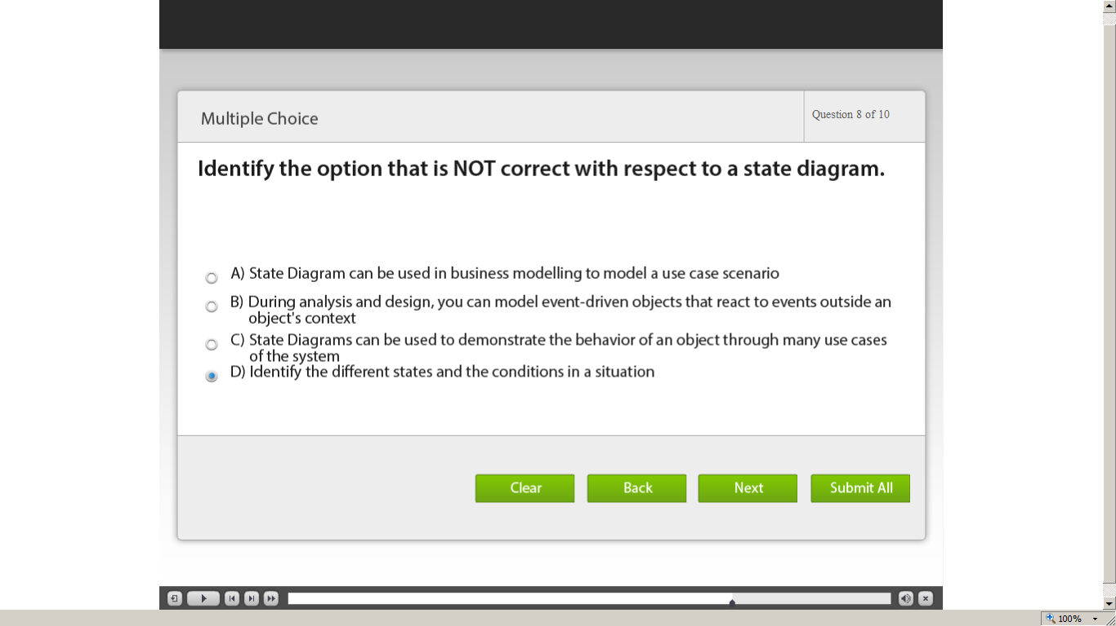](https://compass.learning.cognizant.com/elmprd/elearning/l2_ad_practicinglead_statediagrams_test_your_understanding/l2_ad_practicing%20lead_state%20diagrams_test%20your%20understanding.htm)

[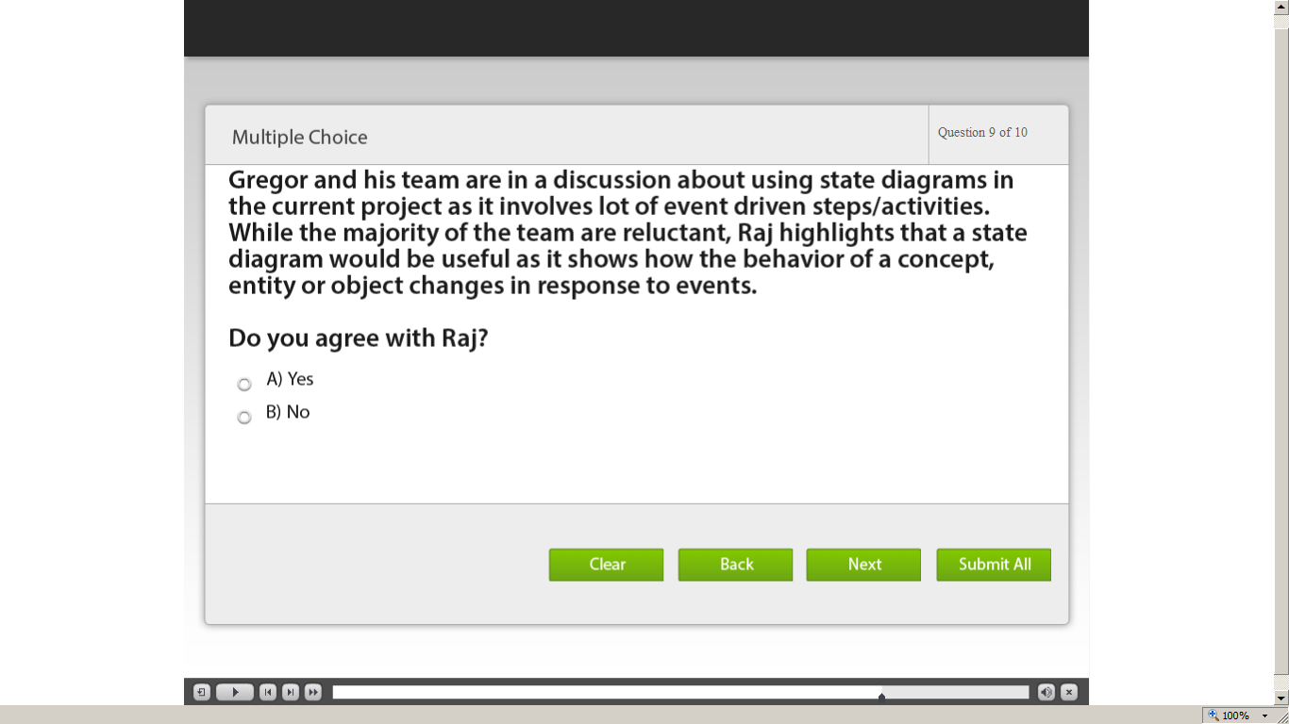](https://compass.learning.cognizant.com/elmprd/elearning/l2_ad_practicinglead_statediagrams_test_your_understanding/l2_ad_practicing%20lead_state%20diagrams_test%20your%20understanding.htm)

[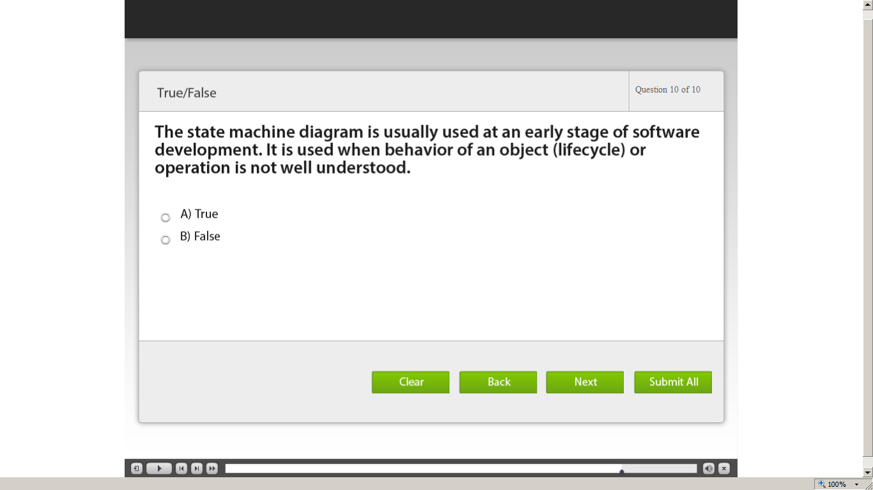](https://compass.learning.cognizant.com/elmprd/elearning/l2_ad_practicinglead_statediagrams_test_your_understanding/l2_ad_practicing%20lead_state%20diagrams_test%20your%20understanding.htm)